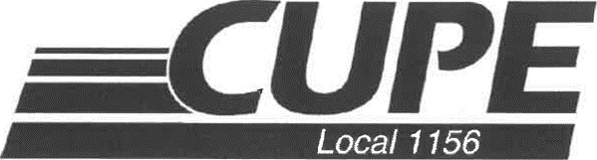

**RATIFICATION VOTE**

**FOR NEW COLLECTIVE AGREEMENT**

**DATE: Wednesday, October 16, 2024**

**LOCATION**

**UC: 6 -005**

TIME: 6:30am to 5pm

**LC: Room 229**

Time: 7am to 4pm

**BC: Room 301**

Time: 6:30am to 5pm

**PLEASE BRING YOUR UHN ID BADGE**

**Vote at the closest Location near you**