


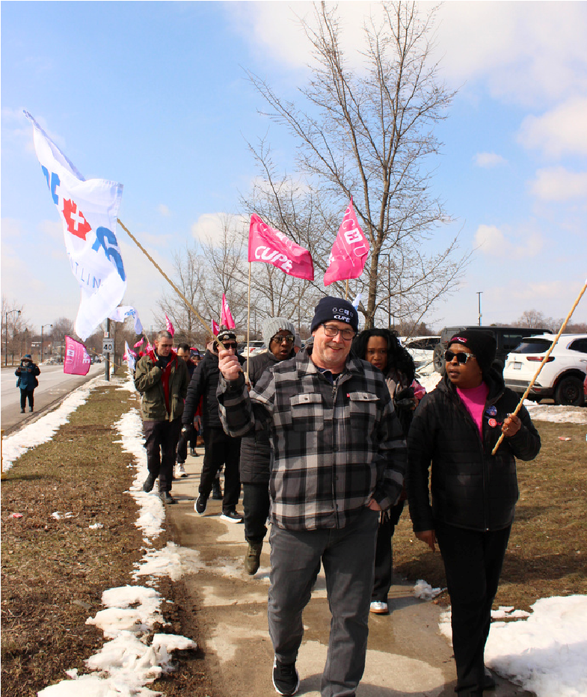

Rally Against the

Health Care Cuts
Lakeridge Health Oshawa Site,
Across at Alexandra park
April 23, 2026 - 12:00PM
Unmanageable workloads and job cuts are taking a toll
on staff and patient care.
It's time to fight back!

